Deploying War To Tomcat8:

1. First install maven,Git,Java in Jenkins server

https://tecadmin.net/install-apache-maven-on-centos/

1. Now in Jenkins go to Manage Jenkins🡪manage plugins

Install Maven-integration plugin and Deploy to container plugin

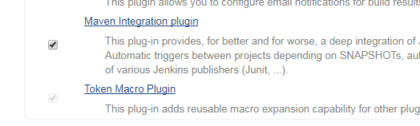

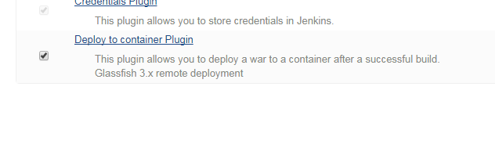3) Now go to manage Jenkins🡪Global tool configuration🡪

Click on add java path and add home path of java

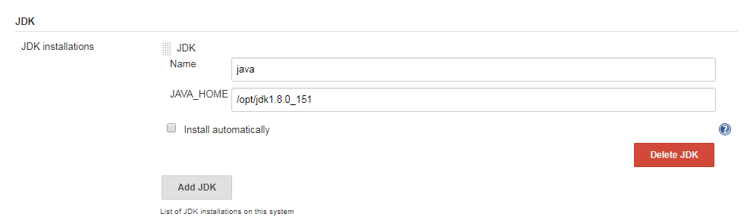

Click on add maven path and add maven home path

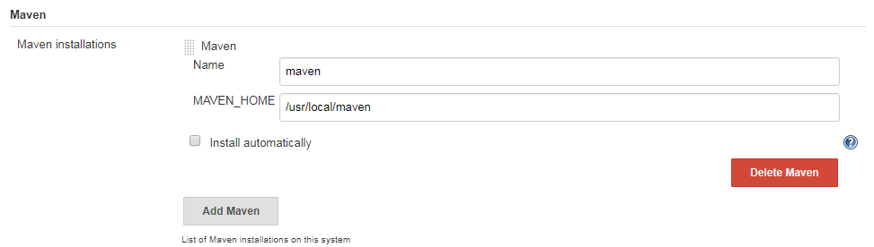

Save the settings.

1. Now create a new project by name maven(project name is your wish )
2. In source code management select Git and give the following url

<https://github.com/gabrielf/maven-samples.git>

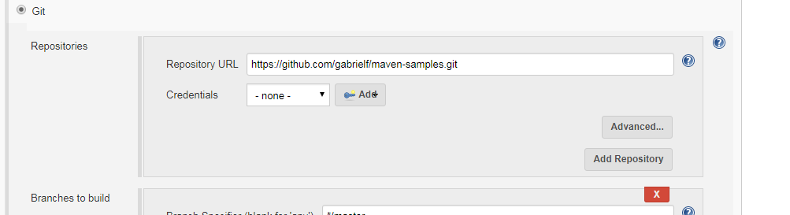

1. In build step these are steps need to be filled

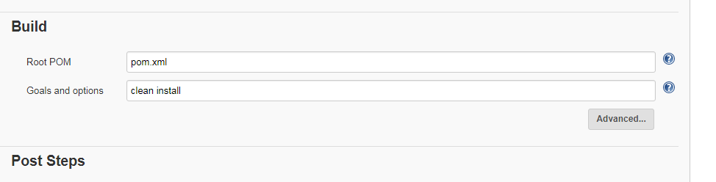

1. In post-build actions select Deploy to container war/ear option

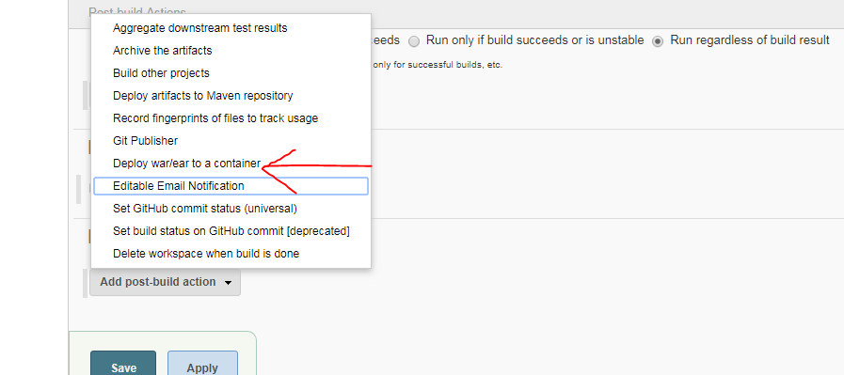

1. After this add context path (any name),and war type mentioned in screenshot

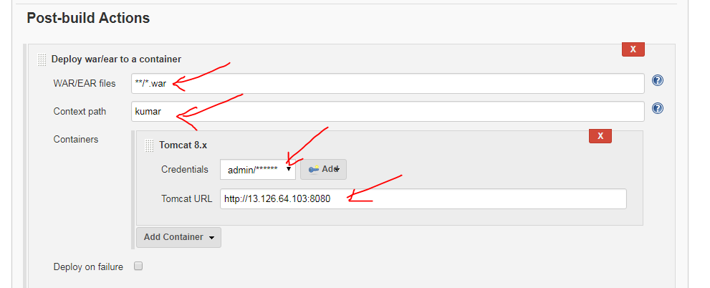

1. Click on add credentials ,select username and password and add

Username: admin

Password: admin

This are the credentials we defined in tomcat user creation

 <role rolename="manager-gui"/>  
<role rolename="manager-script"/>  
<role rolename="admin"/>  
<user username="admin" password="admin" roles="admin,manager-gui,manager-script"  
/>

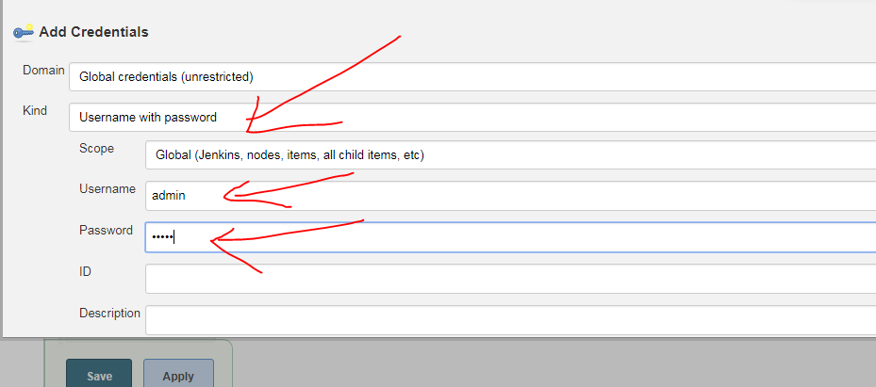

1. Add the credentials and select the user in dialog box and mention tomcat url. In my case

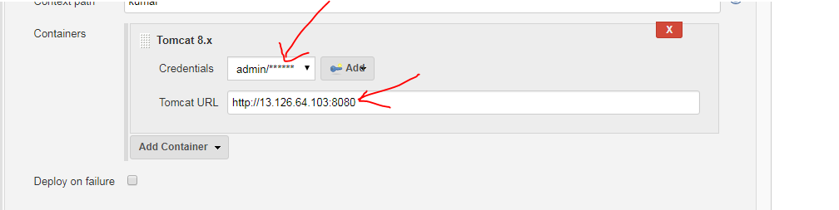

1. Save the project and run the build now

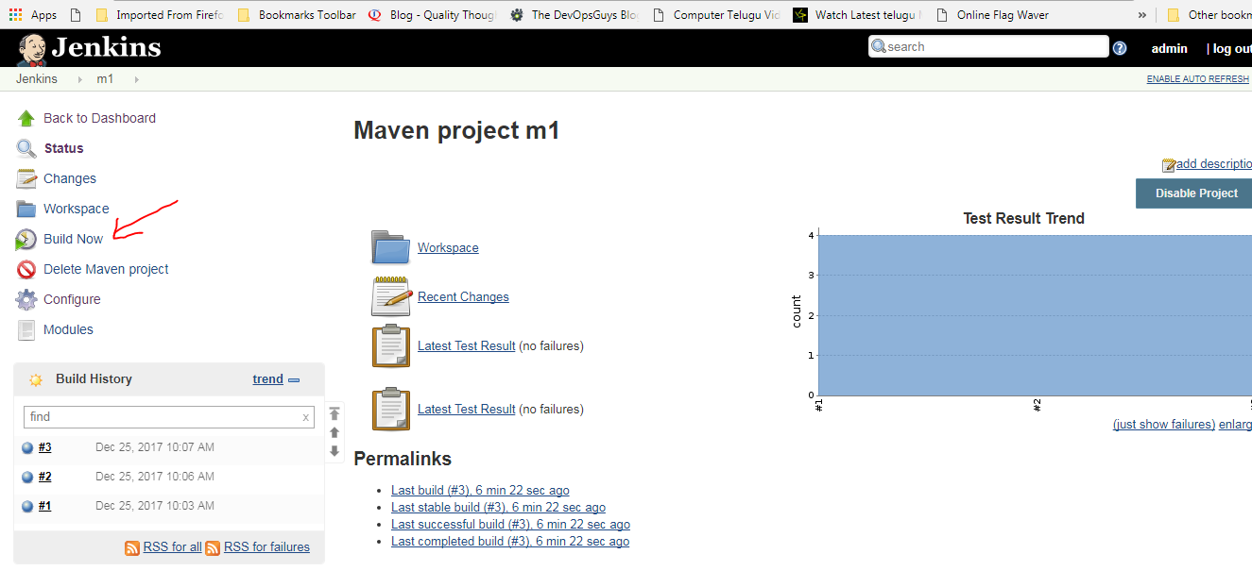

1. If you see the console output like this

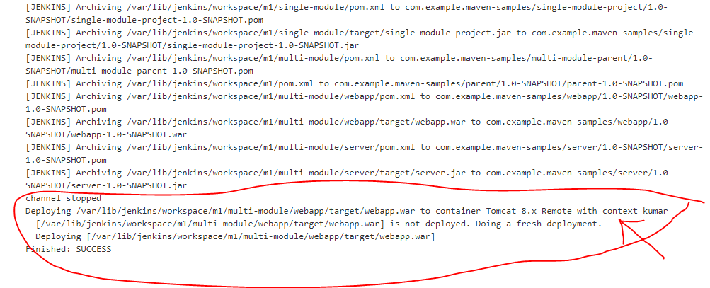

It is deployed to tomcat

14) Open tomcat web browser you will see the sample application with context name

